Identifying problems & Understanding Business

Problems and Motivations:
Air Pollution in Hanoi and other regions

The characteristics of craft village activities, such as small-scale production, outdated and asynchronous technology, spontaneous development, mainly developed according to market demand (Nguyen, 2020)

PM2.5 can penetrate deep into the lungs and enter the bloodstream, causing respiratory and cardiovascular issues (Chen, 2020)

Hanoi, the capital of Vietnam, is particularly vulnerable to air pollution due to its high population density, economic growth, and reliance on private motor vehicles (Vanderbloemen, 2025)

Pain Point and Why it should be resolved:
“I have been exposed to particulate matter (PM) in the past five years”
“Top environmental health issues that concerned adult residents in densely populated areas. The most selected issue was air pollution”
Affecting people health and lifestyles, can
-> I need an application that can solve my existing problem of air pollution
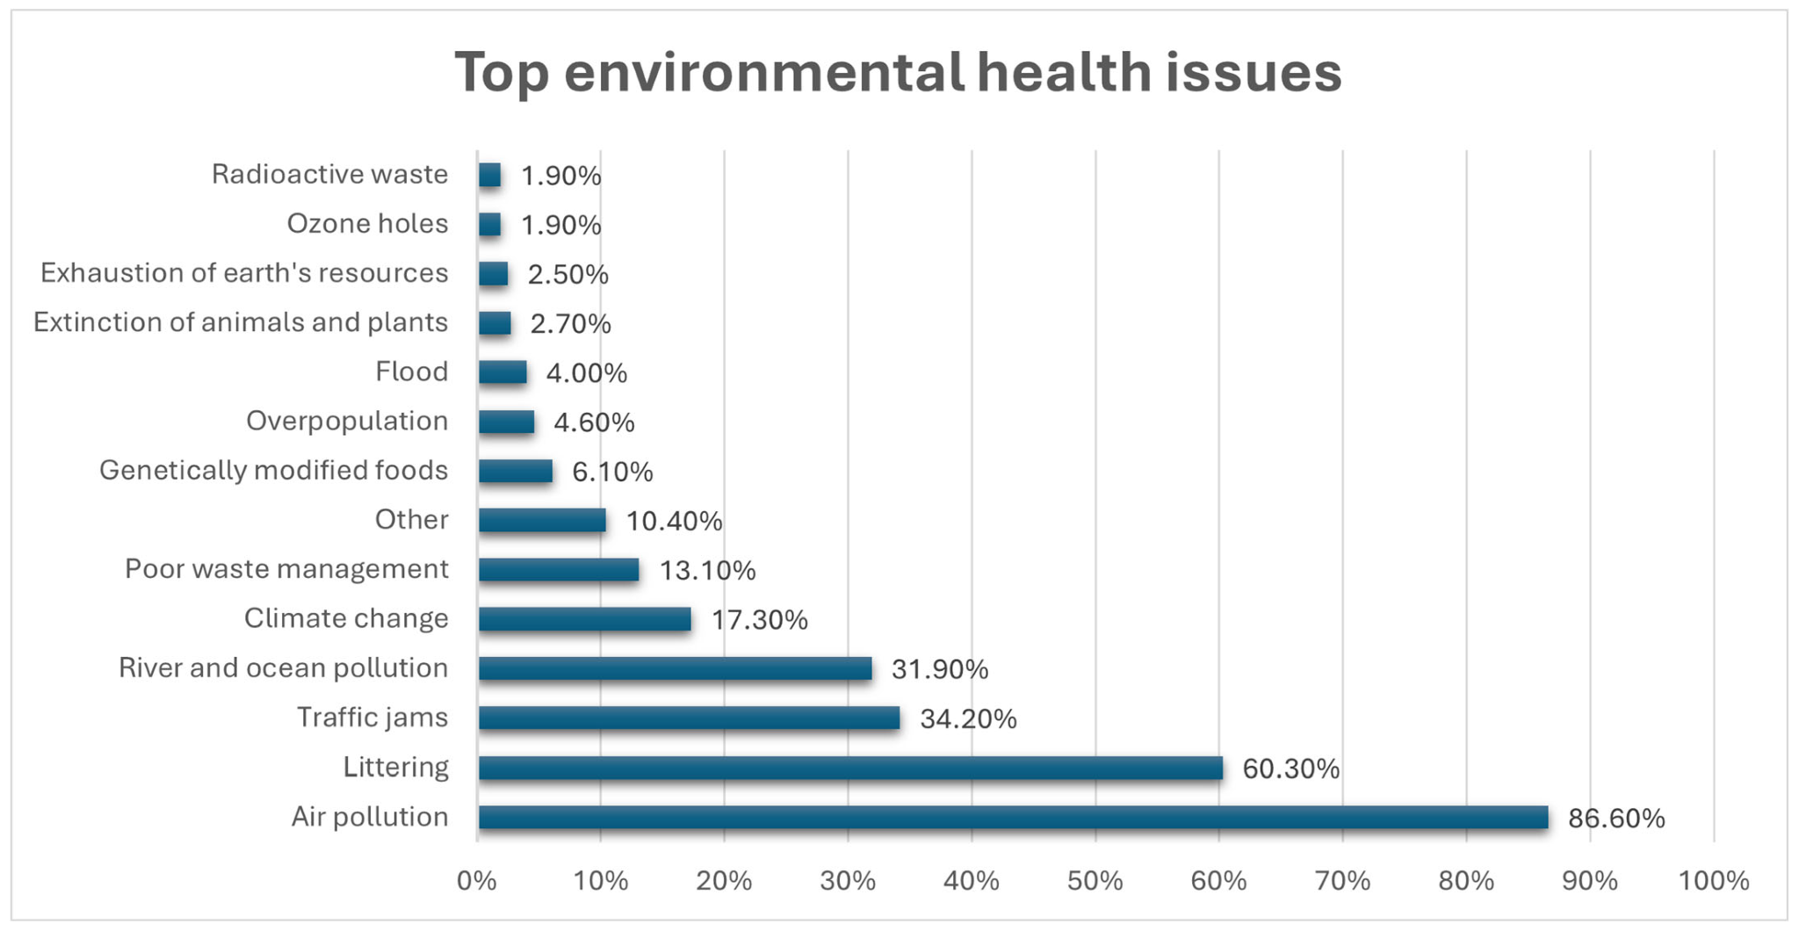
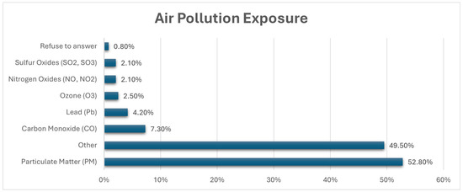

Solutions:
Air Quality Predictors using Machine Learning Algorithms, with Interactive Dashboard
Understand the need for a solution that can help residents be aware of the air condition, and make it easy to access for users.
Inspiration: IQAir, Da Ton Commune, Hà Nội, Vietnam Weather Forecast | MSN Weather

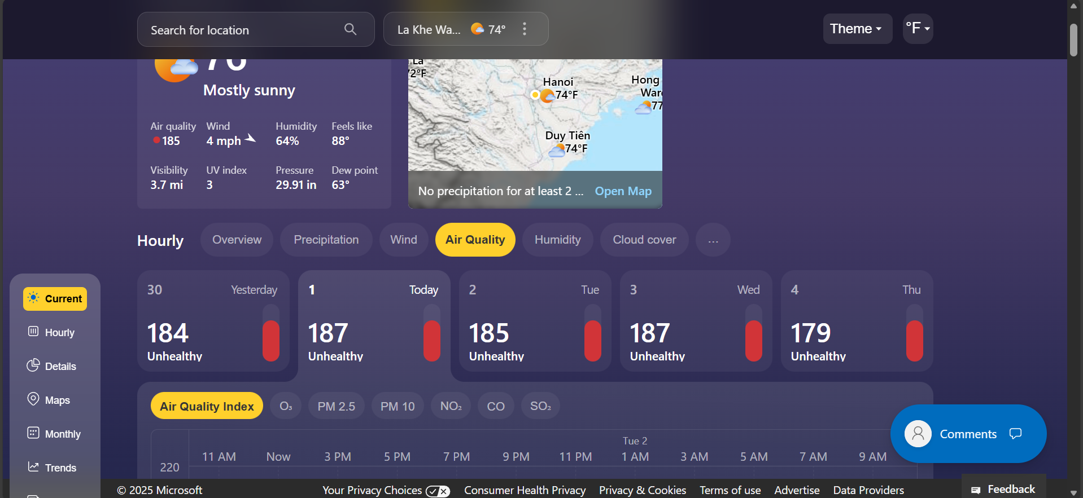

Functional Requirements:
- Integrate with Machine Learning models and algorithms like Bi-LSTM
- Interactive Dashboard Application, easy-access for users, with up-to-date information
Opportunities:
- Become a real project to be used in densely populated areas and megacity that is located near craft and traditional villages.
- Collaborate with environment institution like CEI (Center for Environmental Intelligence)

Potential value and risks (including ethical aspects) of the business project
SWOT:

Strengths | Weaknesses
- Integrate with Machine Learning models and algorithms like Bi-LSTM  - Interactive Dashboard Application, easy-access for users  - Relatable to users living in densely populated areas and near traditional craft villages | - The real-life applications have not been verified  - The needs for expensive techniques such as IoT sensors, if turning into a real application  - Potential gaps in data availability/quality, especially for localized PM2.5 measurements in Vietnam.
Opportunities | Threats
- Raising the awareness of Vietnamese users, especially densely populated areas like Vinhomes and Ecopark  - Collaborate with environment institution like CEI (Center for Environmental Intelligence)  - Integration with smart-city ecosystems, supporting policy-making | - Regulatory constraints, data Authorization from Governments if necessary  - Competitive market, many opponents have been published some of the same applications  - Risk of model misinformation, where inaccurate predictions may cause public panic or distrust.

Reference:
- Vanderbloemen, L., Liamputtong, P., Nguyen, O. T. K., Hoang, K. V. N., Huynh, H. X., Hoang, M. P., Tran, M. G., Nguyen, P. H., Pham, T. N. H., Kapil, D., Elgebaly, A., & Taylor-Robinson, A. W. (2025). Hanoi Air Quantitative Report: A Cross-Sectional Study of Knowledge, Awareness, and Sustainable Practices Related to Air Pollution Among Residents of Hanoi, Vietnam. Sustainability, 17(14), 6557.
https://doi.org/10.3390/su17146557
- Chen, J.; Hoek, G. Long-term exposure to PM and all-cause and cause-specific mortality: A systematic review and meta-analysis. Environ. Int. 2020, 143, 105974
- Nguyen, T.L. (2020) Environmental pollution in Vietnam’s craft villages E3S Web of Conferences, InterAGRO-MASH 2020, 35, 06012. https://doi.org/10.1051/e3sconf/202017506012

